

***Local Land Charges external release notice***

***Release number: Various releases up to 10_2***

***Release Date: 21/11/2023***

***Service: Search for local land charges***

* Enhancements to the ‘Copy from map’ function in Search service, making it the preferred way to easily capture accurate search extents.
* *When selecting multiple polygons from the OS Map which overlap or adjoin, the polygons are now automatically merged to form one search extent.*
* *‘Copy from map’ now works with many more features on the map, including gardens, roads, rivers, ponds and coastlines. Simply click within an enclosed area to create an extent.*

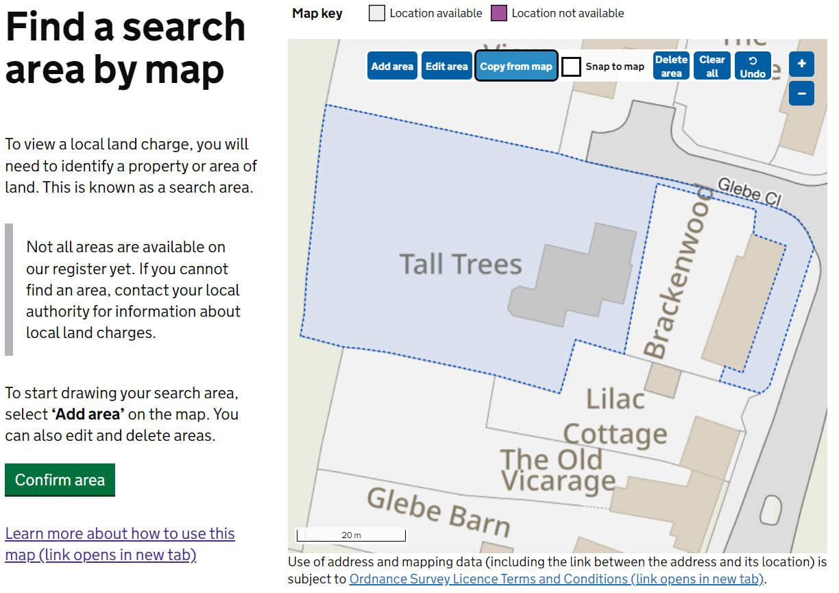

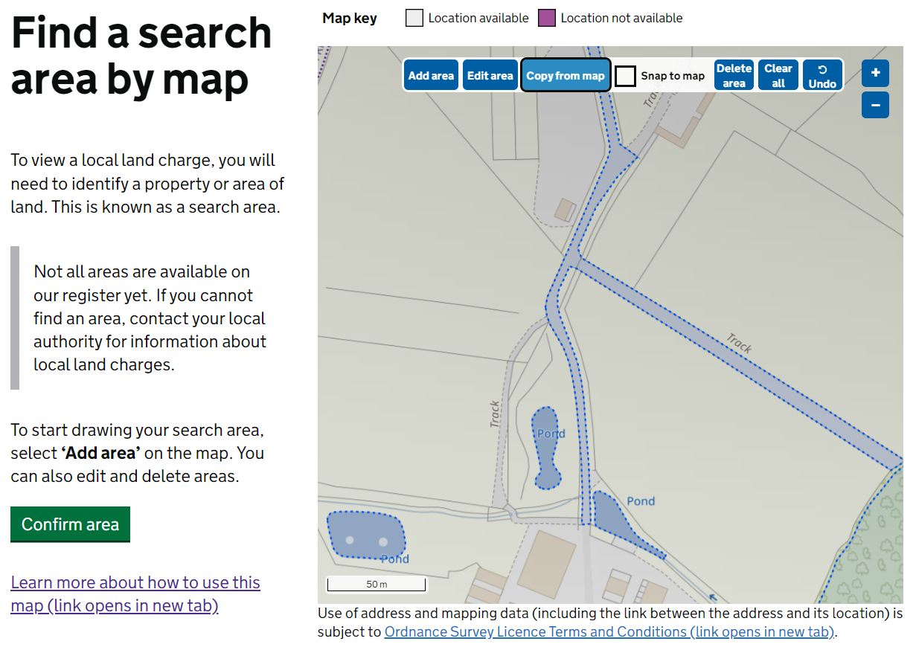

* Updated ‘How to use the map’ page

*The ‘*[*How to use the map*](https://search-local-land-charges.service.gov.uk/how-to-use-the-map)*’ page has been updated to include latest enhancements to map functionality, such as ‘Copy from map.’*

* Update Search service Government Digital Service (GDS) toolkit.

*A significant piece of work to update the Search service to the latest GDS service toolkit.  This has addressed several accessibility issues and helps to keep us in line with latest GDS standards in future.*

* A link to a Release Notice repository has been added to Search for local land charges. This is the first release notice to be added.
* Improved searching across migrated and non-migrated local authority boundaries to improve user experience.